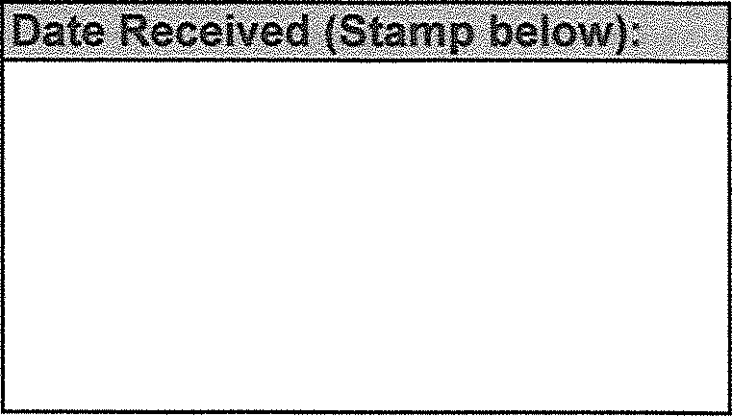
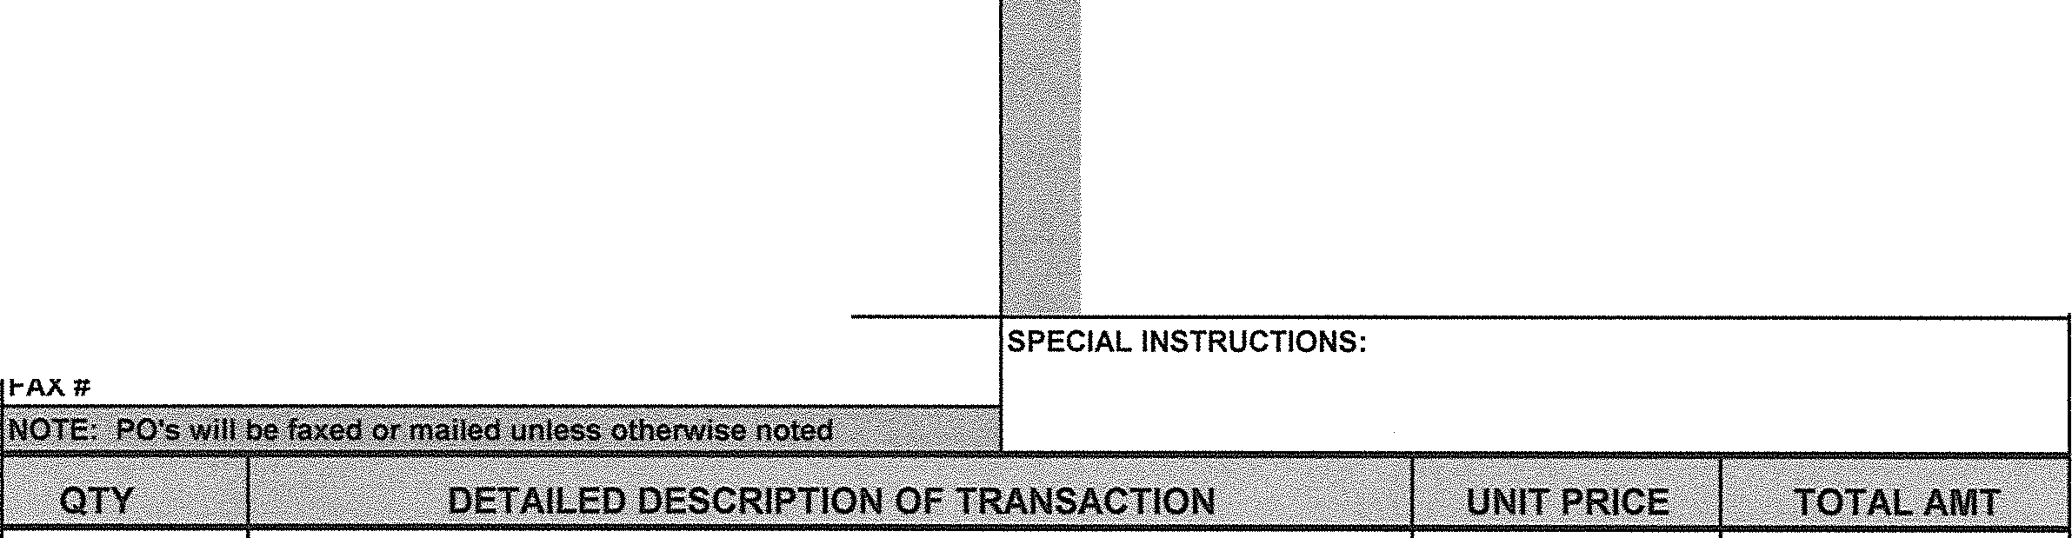Date: BLOOMSBURG UNIVERSITY
INCLUDE NAME, ADDRESS, ZIP CODE AND FAX NUMBER OF FIRM. IF VALUED AT S5, 000 OR GREATER, BIDS MUST BE ATTACHED.
k·)ee:,,-
VENDOR I PAYEE: NAME - ADDRESS - FAX - PHONE:
SHIP TO ADDRESS (FOR PO'S ONLY):
PHONE#

HUSKY FUND
Request for Deposit: Request for Payment:
Request to Purchase:

NAME OF ACCOUNT ACCT#

LINE ITEM EXPENSE/ CHARGE DESCRIPTION:

NOTES (ie. "will pick up check". needed by dates. mail with forms. etc.): |  | Check Total:
 |  | Cash/Coin Total:
 |  | Deposit Total:
Requested by: Faculty Advisor/Administrator:

Signature Telephone# Signature Telephone#

COMPTROLLER
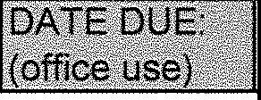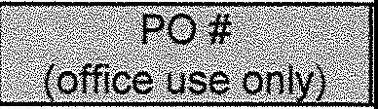

PLEASE READ CAREFULLY BEFORE FILLING OUT THIS REQUISITION

- All requests for purchases or allocations, of any kind are to be initiated on this form.

- All requests to purchase require a purchase order.

- A direct purchase without a purchase order may be made ONLY IN AN EMERGENCY to prevent a breakdown in necessary institutional services.

When such purchases are necessary, they must be reported on this form (including a justification for the purchase) the next business day, in order that a confirmation order may be placed immediately.

- A minimum of three (3) bids is required for purchase orders over $5,000.00.

A purchase order must be issued by the Community Activities Office, in advance of any purchase.

- All receipts, invoices, etc. should be attached to this form for payment.

- All requests for special needs (payment by certain date, mailing check, holding check, etc.) should be noted in the "notes" section of this requisition.

NOTE: ALL GRAPHICS FOR PURCHASE ORDERS MUST BE SUBMITTED ON A SEPARATE FORM ALONG WITH REQUISITION.

